
Project Completion Report

Course Name: Web Application and Internet
Course ID: CSE 309

Submitted to
Faculty Name: Sanzan Adnan Alam
Email: sanzar@iub.edu.bd
School of Engineering , Technology & Sciences
Independent University, Bangladesh

Submitted by

Name | ID
Asif Abdullah | 1931167
Mahfuja Khanam | 2021967
Anindita Modak | 2022017
Abdullah Al Mahmood | 2022238

Submission Date: 13 December 2023

Book Store
Abstract
This study summarizes the design, development, and deployment of a dynamic online bookshop built with Tailwind PHP, SQL, HTML, and CSS. The website has several panels with different functionality for customers and administrators. Customers may simply browse, purchase books, voice concerns, and write reviews. User-created profiles contain a record of every transaction they make. Using the admin panel, administrators can manage user profiles, resolve complaints regarding services, and schedule inventory. The system design is rather detailed and emphasizes the data flow between the front-end and back-end components. Both administrators and users are guaranteed safe access through user authentication and permission mechanisms. The paper examines the intricate back-end development that underpins the functionality of the website in addition to the adaptable front-end design that works.
Introduction
In a time of digital change, our team has successfully developed the dynamic and user-centric Bookstore Website Project to meet the evolving needs of book lovers. Our aim was to create a seamless online book purchase experience by creating a community of engaged readers and streamlining transactions through a fluid platform. A shared passion for books and the goal of providing a digital space that transcends traditional bookshop boundaries served as the driving forces behind this project. We felt that a comprehensive and user-friendly platform was required, so we set out to design a website that not only offers a large selection of books but also includes interactive features to improve user interaction.
Our main goals are as follows:

i. Create a platform that prioritizes user needs, paying close attention to accessibility, usability, and a fun online experience.

ii. Create distinct but connected panels for users and administrators, each based on their needs and duties.

iii. Establish a robust database structure to efficiently manage user data, book details, and transaction records.

iv. Check the security of the processes for user authentication and authorization before enabling customized user profiles and administrator access restrictions.

In order to accomplish these, we used Tailwind, PHP, MySQL, HTML, and CSS. This fusion of front-end and back-end technology builds the foundation for an aesthetically pleasing, flawlessly operating, responsive.This fusion of front-end and back-end technology builds the foundation for a responsive, aesthetically pleasing, and flawless platform.

As we delve into the specifics of the Bookstore Website Project, this report aims to provide a comprehensive overview of the architecture, features, database design, user interaction flow, and upcoming enhancements. In order to showcase our successes and offer motivation for further developments in the ever-evolving world of online bookselling, we plan to share our experiences.

Methodology
The methodology used to plan, design, implement, test and evaluated as a fluid, iterative process including collaboration, feedback, and adaptation, the agile software development strategy served as the foundation for the website's evaluation. Each phase of the software development life cycle involved the procedures, tasks, activities, and deliverables listed below:

Planning: Software engineers convened meetings at this phase to facilitate discussions and gain a deeper understanding of user expectations. The bookshop website's goals, deliverables, and scope were established. The estimated resources and duration for the project. A project plan including actions, deliverables, and milestones was created by the developers. A risk assessment was conducted to determine potential risks and ways to mitigate them. For the project plan and risk assessment, developers spoke with one another to make requirements and expectations clear.

Information Gathering Methods:
The primary goal of an information gathering strategy is to compile all of an organization's and analysts' use-case-specific organization's data. Information collection can be done using a variety of methods.
Questionnaires: Questionnaires are a popular data collection technique used in system analysis to gather information from stakeholders and users about their needs, preferences, and opinions related to the system.Here We attached some survey question and the result we get after collect data from 25 peoples.
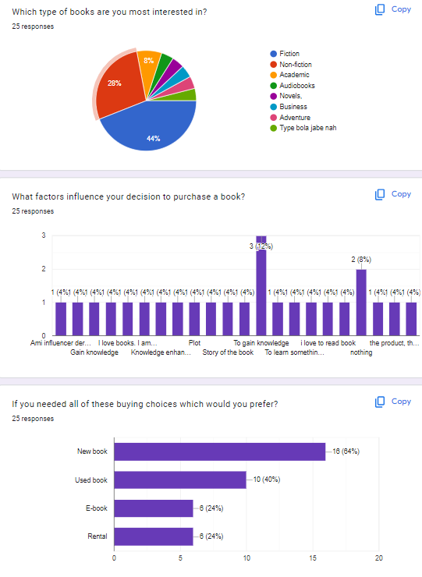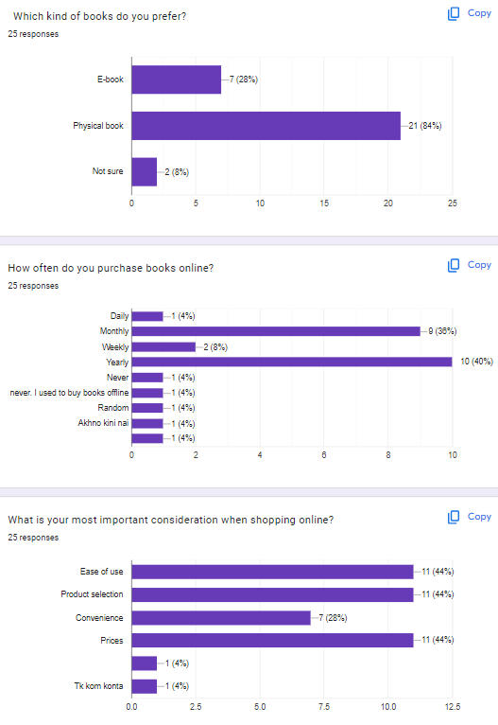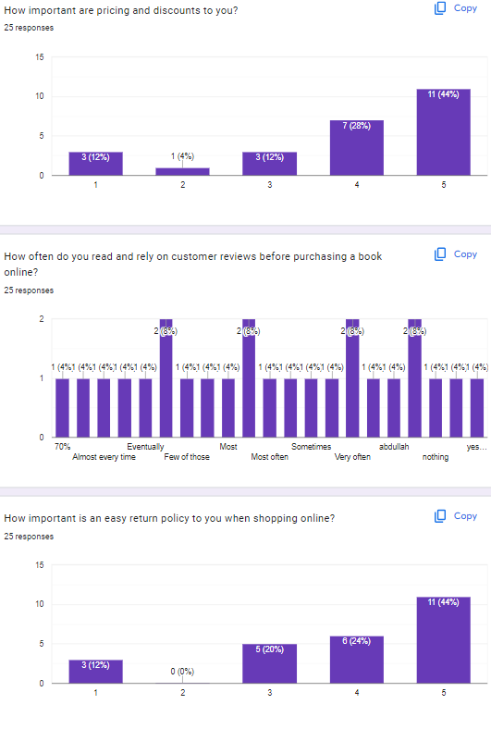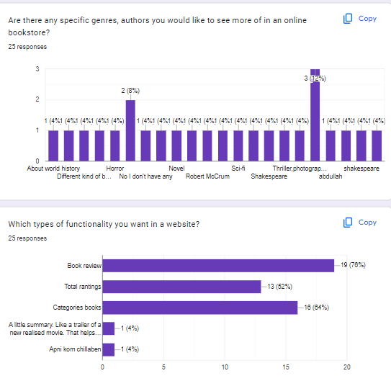

Design: HTML, CSS, and Tailwind CSS were used by developers to construct a user-friendly and visually appealing website. Additionally, they used MySQL to construct a database architecture and data strategy for smooth information organization. The developers used flowcharts, pseudocode, and algorithms to transform the conceptual framework into a working system. Stakeholders were approached for permission and input after the design was finished. This cooperative method made it possible to solve problems, make ongoing improvements, and match the project's goals. Stakeholder approval of the final design represented a significant development milestone.

Implementation: In the website deployment phase, the development team expertly integrated PHP, MySQL, HTML, CSS, and Tailwind CSS. Ensuring the codebase's scalability, maintainability, and clarity required strict adherence to established coding practices, standards, and guidelines. Version control and documentation tools were systematically employed to manage the codebase in an efficient manner, facilitating collaborative development and easy change tracking. Administrators and users received frequent updates on status and progress throughout the deployment process, promoting transparency and keeping all parties informed. The development process required strong teamwork and communication as the team actively solicited feedback and approval from administrators and users. Strict methods of quality assurance were implemented to guarantee the consistency and quality of the code.

Testing: The individuals responsible for developing the website utilized diverse testing techniques to ascertain the resilience and dependability of the system. They worked on frictionless activities like book purchases, reviews, and complaints in order to create a user-friendly experience. Tests of usability were conducted to ensure that communications between administrators and customers were seamless. Performance reviews were conducted in order to locate bottlenecks and resolve issues. Security protocols were assessed to ensure that private data was protected and that various browsers and devices could communicate with one another. Clear communication was kept throughout the process, and stakeholders were regularly updated on testing results and advancement, facilitating collaboration and well-informed decision-making.

Evaluation: After the website was tested, users and administrators both offered insightful feedback. This feedback became the basis of an iterative refining process that the development team labored to address issues that were brought to light and enhance the user experience in general. The website was updated often in response to feedback received from multiple iterations. After that, final evaluations were conducted, considering the views of administrators and customers, to ensure that all requirements were fully achieved. An important project milestone was the administrators' and users' acceptance of the final version. In order to gather information for upcoming projects and to provide a platform for the ongoing progress of development processes, lessons learned and areas for improvement were documented. After completing these tasks, the project closure process may start.

Result and Discussion

Result
User-friendly Interface: The website's implementation section used HTML, CSS, and Tailwind CSS to create an aesthetically pleasing and intuitive user experience. This approach offers a seamless interaction while putting the user experience first. While responsive design principles offer uniform and ideal experiences across all platforms, intuitive design facilitates seamless interaction across several devices. The website's emphasis on user-friendly design is indicative of its objective to offer an aesthetically pleasing, functional, and easily navigable platform to a broad range of users.

Secure and Efficient Backend: The proper application of PHP and MySQL has reinforced the website's backend, giving safe user authentication and efficient data administration a solid foundation. PHP, a server-side programming language, and MySQL, a trustworthy relational database management system, provide easy communication and interaction between the frontend and backend components. The backend procedures prioritize security, ensuring secure processing of sensitive data and robust user authentication.

Functionalities for Customers: The website is user-friendly and allows customers to browse books, make purchases, post reviews, and register complaints. The iterative development method has made it feasible to integrate features that are focused on the needs of the client. By gathering input, testing revisions based on results, and prioritizing additions that directly impact the user experience, the development team has made improvements. This approach not only finds and fixes issues, but it also considers valuable input from administrators and customers. Designed to meet the needs of a diverse user base, the website provides a seamless and intuitive experience for a variety of activities.

Admin Management: According to the characteristics of the website, administrators have effective administrative powers that allow them to manage user profiles, book inventories, and service complaints. The system design was carefully considered in order to provide seamless data flow between the front end and back end, which enables the admin functions to function efficiently and smoothly.

Security Measure: To safeguard user information and maintain data privacy, two crucial security measures are implemented: data encryption and secure login procedures. The first priority is security. The focus on robust security measures demonstrates the dedication to providing a secure and dependable platform for both administrators and users.

Responsive Collaboration:The agile methodology used in the development process encourages responsive engagement with stakeholders, including administrators and customers, across the whole life cycle. This agile methodology ensures that user input is actively considered in real-time by enabling continuous feedback loops. This commitment to flexible collaboration and continuous improvement

Discussion
Enhancing Customer Experience: In order to improve the customer experience, future iterations of the website might focus on personalized recommendations based on user preferences or past purchases. A more user-friendly search and filtering mechanism would make it quicker and easier for users to find the content they're looking for.

Expansion of Admin Features: Analytics dashboards providing information on sales patterns, best-selling novels, and user behavior may be the focus of future development on admin features. Additionally, automating certain administrative tasks, such as handling routine complaints, may increase process efficiency and free up administrative resources.

Continuous Security Measures: It's critical to keep security in mind at all times. Regular security audits and upgrades are necessary to handle emerging threats and vulnerabilities. Enhancing security protocols, such as implementing two-factor authentication, may fortify user accounts' resilience against cyberattacks.

Scalability and Performance: As the online bookstore grows, scalability must be considered. Easy expansion must be supported by the system architecture and database design. Examining caching strategies and other optimization approaches might help ensure fast loading times even during peak usage.

Training and Documentation: It may empower users and lower the volume of support queries if consumers are encouraged to read comprehensive user guides. Administrators may benefit from having training sessions or tutorials organized to help them make the most of the admin features.

Feedback Mechanism: A lack of a solid feedback system on the website could help identify areas in need of improvement and encourage further user involvement. The bookshop website is regularly analyzed and adapts to user feedback in order to make iterative improvements that meet the evolving needs and expectations of its users.

SWOT Analysis

Strengths: The use of HTML, CSS, and Tailwind CSS enables the website's visually appealing and user-friendly design. It offers consumers a number of features, including the capacity to peruse, purchase, evaluate, and report issues with books. Administrators are competent in managing a wide range of management duties, including planning inventory and responding to client concerns. Two crucial strategies for safeguarding user information and maintaining data integrity are encryption and secure login procedures. The platform's agile methodology fosters responsive stakeholder cooperation throughout the product life cycle, allowing for continuous feedback loops and incremental improvements. This approach ensures that the website will always be adaptable and responsive to the shifting needs and desires of both administrators and users.

Weaknesses: As the current admin and user features are sufficient, there is need for improvement to enhance the overall user experience. This may mean adding new features that take into account consumer needs and technological advancements. Scalability becomes more crucial as the user base grows, and system architecture and database design need to be routinely assessed to identify bottlenecks. In order to maintain a positive user experience when expanding, a proactive approach is needed. Developing comprehensive administrator training programs and user manuals could enhance both user comprehension and operational effectiveness. By offering resources and training, users may gain better proficiency and self-assurance when utilizing the system.
Opportunities: Improved search and filtering capabilities as well as tailored recommendations could improve the user experience. This would facilitate book finding and provide a more engaging experience. Using automated task management and analytics dashboards, managers may optimize their processes. Ongoing security procedures, such audits and updates, are essential to protecting sensitive data and user confidence. Performance optimization strategies like caching, which lead to faster loading times and a more enjoyable surfing experience, can improve website performance. These adjustments can enhance customer satisfaction as well as the overall operation of the website.

Threats: The dynamic nature of the internet poses security threats and demands constant observation to protect user data. In a market where competition is intense, it is risky to fall behind rivals in terms of features, user experience, and customer support. It takes creativity and remaining on the cutting edge to keep users. Effective management of customer feedback is essential to maintaining user satisfaction and ensuring that the platform lives up to their expectations. Technology is advancing quickly, which poses a problem if the website isn't adaptable. In the digital realm, competitiveness and compatibility necessitate constant updating and adaptation.

Conclusion
By a particular focus on security and dependable backend technologies, the bookshop website project has effectively developed a feature-rich, user-friendly platform for both administrators and customers, all under the direction of agile software development. The project's strengths include a user-centric design, strong customer and admin tools, and data security, with an emphasis on continuous communication and adaptation. Still, there's room for improvement in areas like enhanced training and documentation, scalability for future expansion, and individualized user experiences. To accommodate changing user needs, future updates should also incorporate performance optimization and sophisticated admin functions. Sustaining a competitive advantage and mitigating potential security threats need constant attention to detail. Although the project's progress is encouraging, the bookshop website's continued success and expansion depend on user feedback and technology advancements.

Here are some screenshot of our projects
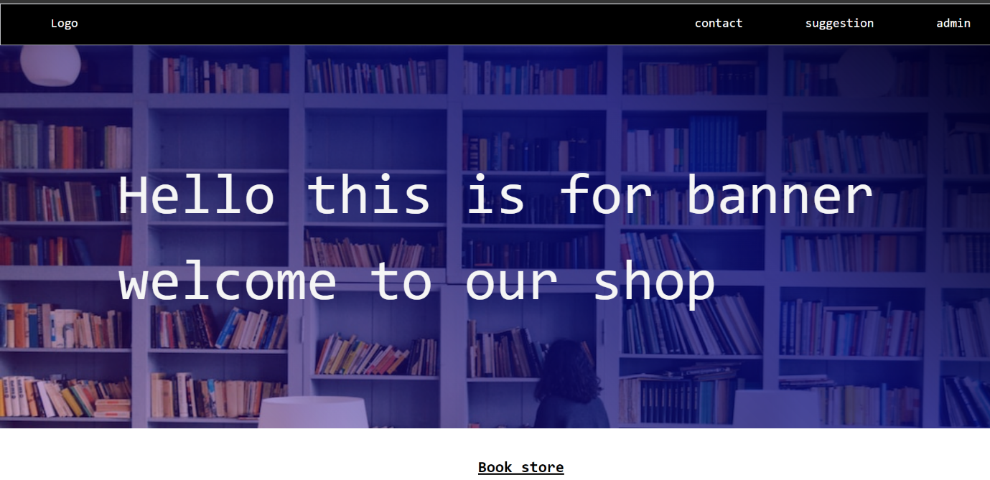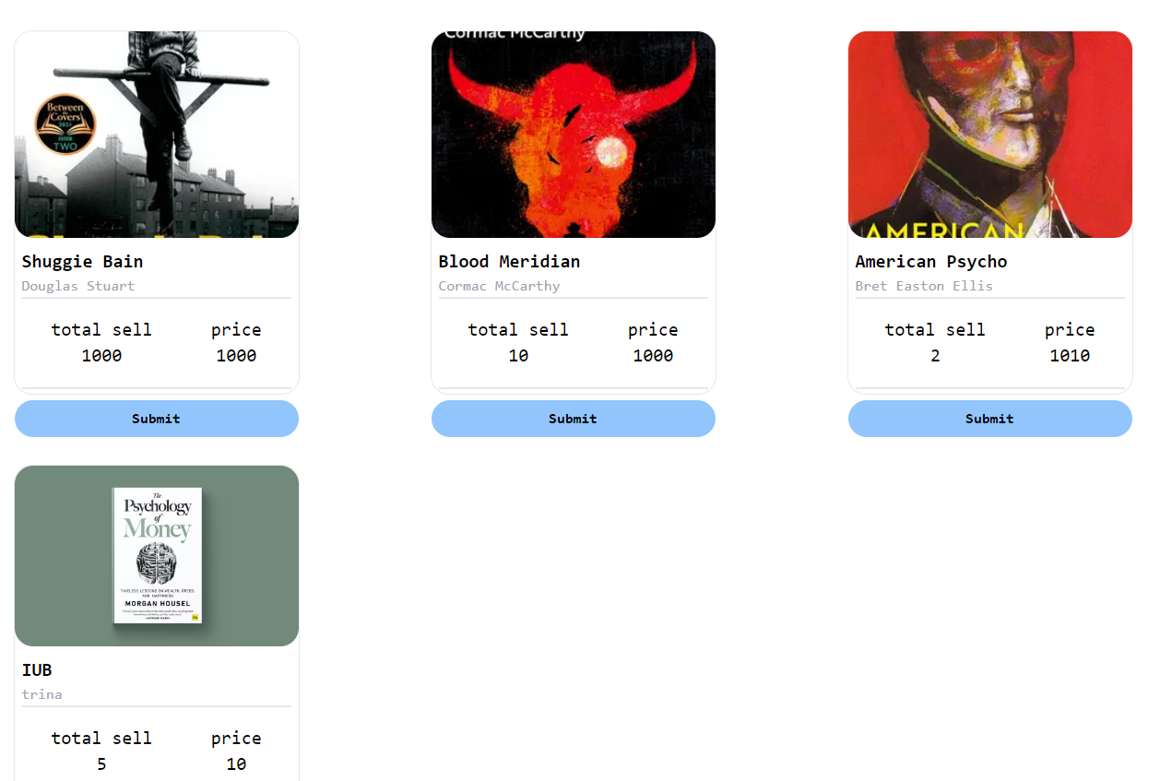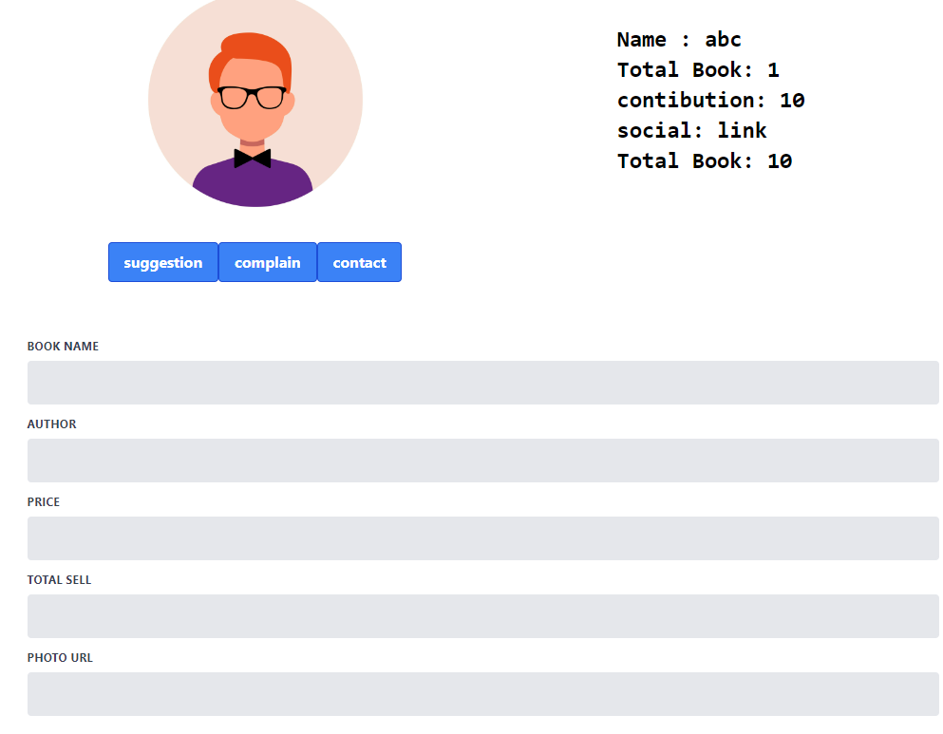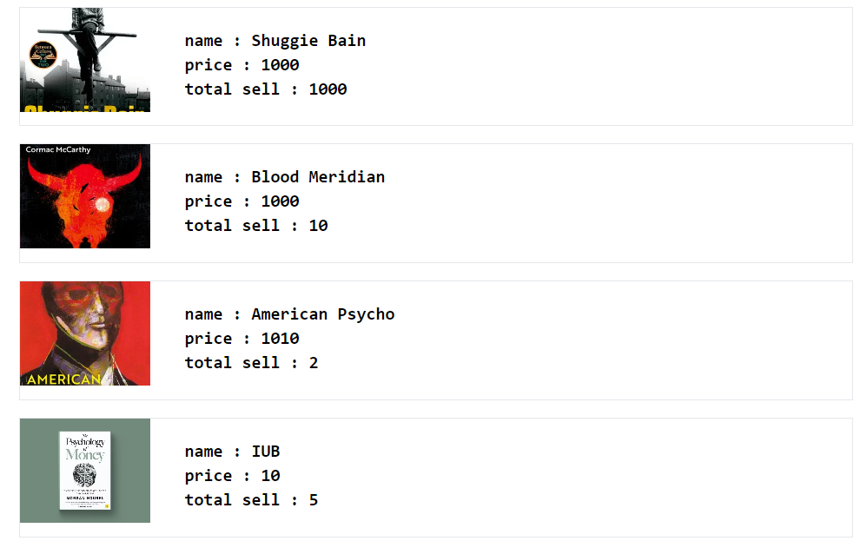

This is the demo video of our project


This is the drive link for video

https://drive.google.com/file/d/1chfsoUsUjsHDl-uApmOD9-3T6fEVb_LE/view?usp=sharing

